Activity report:
“Strengthening capacity of women cross border traders in Mozambique”.
(April 2022 – October 2023)

UNCTAD- TradeMark Africa

Contents
Introduction 2
Project Overview 2
Mozambique Training activities 4
Workshop 4
Outcomes of the workshop 5
Key takeaways from the workshop 7
Policy Review Study 8
Policy Dialogue Roundtable 8
Annex I. Programme 9
Annex II. Photogallery 11

Introduction
This report provides an overview of the activities conducted by the United Nations Conference on Trade and Development (UNCTAD) Trade, Gender and Development Programme under the project on "Strengthening capacity of women cross border traders in Mozambique". Activities were carried out between January and July 2023 and included:

- Training activities
  - Developing a Traders Guide for Mozambique on trade rules and procedures.
  - Planning and holding a series of 4 six-day training workshops; 3 in Maputo (linked to Ressano Garcia border with South Africa) and 1 at the Mandimba border with Malawi.
- Policy Review Study
  - Developing a Policy Review study on “Mozambique’s Integration into Regional Value Chains and the Role of Women Small-Scale Cross-Border Traders”.
- Policy dialogue roundtable
  - Presenting the Policy Review study as well as preparing and delivering presentations on the formation of a National Trade Facilitation Committee (NTFC) Sub-Committee on small-scale cross-border trade at a policy dialogue roundtable for relevant policymakers in Mozambique.
- Final report

Project Overview
The TradeMark Africa (TMA) and UNCTAD Cooperation Agreement was signed in 2015 and implemented during a Phase I and II from early 2016 to 2020 with three components: (I) Trade Facilitation; (II) Trade Portals and (III) Trade and Gender (only for Phase I).
A new collaboration was agreed upon between the two institutions on 11 April 2022 under the title: STRENGTHENING CAPACITY OF WOMEN CROSS BORDER TRADERS IN MOZAMBIQUE (2022- 2023). The objective of the collaboration was to enhance cross border trade between Mozambique and some of its neighbouring countries, specifically South Africa and Malawi, through the promotion of trade facilitation, and by enhancing the capacity of related stakeholders and institutions to implement trade procedures, and make trade more inclusive and beneficial to all. The framework for this programme was through the TMA Mozambique Safe Trade Programme, as well as TMA’s Trade Facilitation programme for Mozambique whose overall objective is to increase trade competitiveness.
Within the framework of this collaboration, UNCTAD’s Trade, Gender and Development Programme in the Division on International Trade and Commodities, organized four training workshops in Mozambique that focused on enhancing cross-border traders' entrepreneurship skills and awareness of trade rules and customs procedures. These training workshops were informed and complemented by a series of other activities, including: Mapping of stakeholders through surveys, interviews, and focus group discussions; Assessment of the role of cross-border traders’ associations, women’s groups etc. at the border; Review of the existing trade protocols and practice for small-scale cross border traders and their implementation, focusing on the traders’ rights and obligations; Advocacy on simplification of trade procedures and raising awareness; and Facilitation of dialogues between women traders, cross border officials, and representatives of government institutions. The training activities reached 113 cross-border traders, mostly female traders, and contributed to empowering them through:
- Increasing the knowledge of their rights and obligations as cross-border traders;
- Raising awareness of regional trade rules, particularly the Southern African Development Community (SADC)'s Trade Protocol;
- Increasing confidence in using official borders; and
- Raising awareness on formalising and registering their business and devising new business strategies and improving their entrepreneurship skills.
These activities built on a range of interventions carried out by UNCTAD’s Trade, Gender and Development Programme that formed part of a previous Development Account (DA) project implemented in Malawi, the United Republic of Tanzania and Zambia during 2016 – 2019 "Informal Cross-Border Trade for the empowerment of women, economic development and regional integration in Eastern and Southern Africa", and the inter-agency DA project "Global Initiative towards post-COVID-19 Micro, Small and Medium Enterprises (MSME) sector" carried out in Botswana and Kenya in 2022.

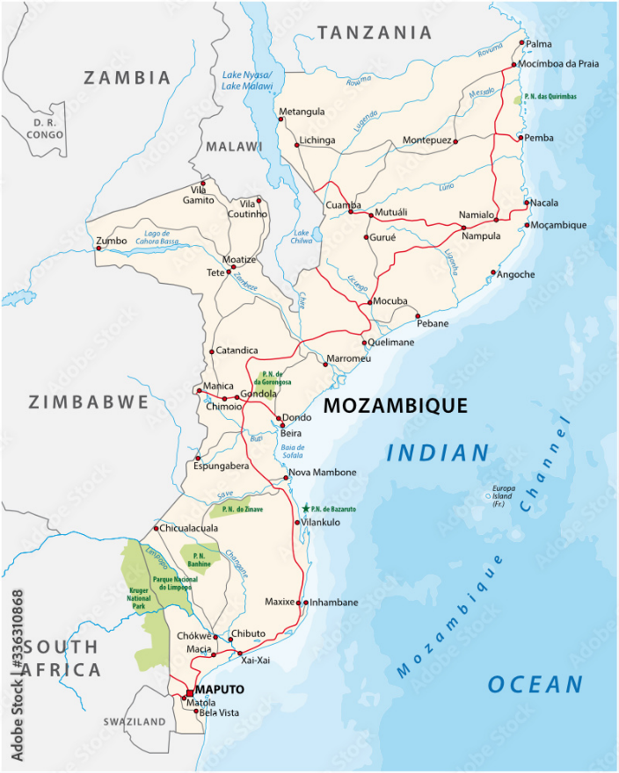
Mozambique Training activities

Workshop
The UNCTAD Trade, Gender and Development Programme organised four workshops devoted to small-scale and informal cross-border traders: Three in Maputo (26 June – 1 July, 3 – 8 July, 10 – 15 July); and one in Mandimba (24 – 29 July). The workshops took the following format - a six-day workshop combining two components: one-day training on cross-border trade rules and procedures and a five-day training dedicated to developing entrepreneurial skills based on the UNCTAD Empretec methodology.
The target group was small cross-border traders operating mainly on the borders of Ressano Garcia, Goba and Namaacha (bordering with South Africa, and the Kingdom of Eswatini) and also on the border of Mandimba in the province of Niassa (bordering with Malawi).
For the identification of participants, UNCTAD requested the Ministry of Industry and Trade to provide the list of potential participants to be interviewed and selected for the trainings. Interviews were conducted by a team of two UNCTAD trainers to assess the entrepreneurial profile of each participant.
Figure 1: Map of Mozambique.
Source: UNCTAD secretariat based on Adobe Stock.
A total of 136 cross-border traders and micro-entrepreneurs were selected to participate in the four workshops and 113 participated in them, as well as several representatives from cross-border traders’ associations and representatives of governmental authorities, namely, Customs, the Ministry of Agriculture and the Ministry of Industry and Trade. The overview of workshop participants disaggregated by sex is as follows:
NUMBER OF PARTICIPANTS DISAGGREGATED BY SEX:
DESCRIPTION | FEMALE | MALE | TOTAL
FIRST WORKSHOP  Maputo-June 26th - July 1st, 2023 | 29 | 3 | 32
SECOND WORKSHOP  Maputo- July,3rd - 8th, 2023 | 29 | 1 | 30
THIRD WORKSHOP  Maputo- July,10th - 15th, 2023 | 22 | 2 | 24
FOURTH WORKSHOP  Mandimba-July 24th - 29th , 2023 | 22 | 5 | 27
TOTAL 4 WORKSHOPS  June 26th - July 29th , 2023 | 102  (90%) | 11  (10%) | 113  100%

Outcomes of the workshops
Day 1 focused on one of the key components of the training – component one: equipping informal and small-scale cross-border traders, especially women, with the knowledge and understanding of trade rules and regulations and customs procedures, particularly on: a) their rights and obligations as cross-border traders; b) the main provisions of the SADC Trade Protocol. The session was based on a Traders Guide for small-scale and informal traders in Mozambique developed by the project team. The Traders Guide presents and analyses regional trade rules and procedures, as well as information on traders’ rights and obligations at the border.
The session began with welcoming remarks from Mr Cameron Daneshvar, UNCTAD Economic Affairs Officer, Trade, Gender, and Development Programme. Mr Daneshvar emphasised the importance of the project in empowering women in their trading activities as well as the importance of formalising their business. For the Mozambican government, welcoming remarks were made by an official from the Ministry of Industry and Trade. This was followed by a presentation on trade rules and regulations, rights and obligations, and interventions from the Ministry of Industry and Trade and cross-border traders’ associations. The presentations also included a Q&A session, which allowed participants to share their experiences and perspectives, and to interact directly with officials and ask clarifying questions. Days two-six focused on the Empretec entrepreneurship module. The full programme of the workshop is attached in Annex I.
The key takeaway points from the discussion of Day 1 can be summarized as follows:

- Traders raised concerns about the relationships between border officials and the traders’ group, resulting mainly from fees perceived to be charged illegally;
- Traders complained that there is a weak access to correct information on trade rules and customs procedures, a factor conducive to excessive use and abuse of power by border authorities;
- Traders complained about poor relationships with South African suppliers, who often disregard the policies and standards that regulate Maputo-South Africa cross-border trade. For instance, some traders are holders of an importer card which gives them rights to transact their goods at a reduced rate, mainly for perishable products, but sometimes this is not recognized or accepted;
- Traders also complained to Mozambican authorities about the lack of security on the roads, due to frequent attacks on trucks transporting their goods, occurring mainly in South African territory;
- As a way to minimize these problems, participants expressed the intention to create digital platforms for sharing information, so to create more cohesion among the group of cross-border traders operating along the Maputo- South Africa corridor;
- The tax authorities’ officials present at these discussions reacted positively and stated that they had listened to and noted the traders' concerns, which would be reported to higher level government authorities;
- Tax authorities were open to resolving these and other problems that may eventually arise in the day-to-day lives of traders, and wished for a more collaborative spirit among Government, Traders Association and traders themselves.

Day 2-6 of the workshops focused on the delivery of the entrepreneurship skill building component through the Empretec methodology. The Empretec training is based on a behavioural methodology to strengthen 10 key entrepreneurial competences that influence the way entrepreneurs manage and run their businesses. The workshop methodology includes exercises, role play and self-assessment tools that aim at helping participants to put into practice such competencies, which can be grouped under three main clusters:
A. Achievement Cluster
1. Opportunity Seeking and Initiatives
2. Persistence
3. Fulfilling Commitment
4. Exacting Efficiency and Quality
5. Taking Calculated Risk
B. Planning Cluster
6. Goal Setting
7. Information Seeking
8. Systematic Planning and Monitoring
C. Power Cluster
9. Persuasion and Networking
10. Independence and Self-confidence

Participants were asked to complete evaluation forms on the two main components of the training. The evaluation forms assessed participants' prior and post-training knowledge and understanding of their rights and obligations, as well as regional trade rules, with a focus on the main features of the SADC Trade protocol. Prior to the training, a considerable number of participants were familiar with the topics delivered, as shown in the table below, as they had a sufficient, good or very good understanding of their rights, obligations, and application of regional trade rules. In average, 70 per cent of them reported understanding their rights, 61 per cent understanding their obligations, and 63.7 per cent understanding regional trade rules.
Participants' prior-training knowledge and understanding of their rights and obligations and of regional trade rules
Topics/Rating | Not Rated | 1  Not Even a Little | 2  A Little | 3  Enough | 4  Good | 5  Very Good | Total
The Rights of Cross Border Traders | 10(8.9%) | 12(10.6%) | 12(10.6%) | 18(15.9%) | 24 (21.2%) | 37 (32.8%) | 113
The Obligations of Cross Border Traders | 17(15%) | 9(8%) | 18(15.9%) | 23 (20.4%) | 18 (15.9%) | 28 (24,8%) | 113
The use of main features of the SACU and SADC Protocols on trade | 17(15%) | 8 (7.1%) | 16(14.2%) | 28 (24.8%) | 11(9.7%) | 33(29.2%) | 113
The post-training results showed positive outcomes, with most participants indicating that the session had improved their understanding of their rights and obligations and of regional trade rules. Participants’ understanding was sufficiently, very much or extremely improved after the training as a result of the discussions on their rights (81.5 per cent), their obligations (69 per cent), and of regional trade rules (71 per cent). The table below provides a summary of the findings from the evaluation post-training.
Participants' post-training knowledge and understanding of their rights and obligations and of regional trade rules
Topic/Rating | Not Rated | 1 | 2 | 3 | 4 | 5 | Total
The Rights of Cross Border Traders | 11(9.7%) | 3(2.7%) | 7(6.2%) | 18(15.9%) | 17(15%) | 57(50.5%) | 113
The Obligations of Cross Border Traders | 21(18.6%) | 5(4.4%) | 9(8%) | 10(8.9%) | 25(22.1%) | 43(38%) | 113
The use of main features of the SACU and SADC Protocols on trade | 17(15%) | 8(7.1%) | 8(7.1%) | 26(23%) | 13(11.5%) | 41(36.3%) | 113

Participants were also asked to provide evaluations on other issues, including whether the training had given them sufficient opportunity to discuss their concerns with customs and other government representatives, and 85 per cent of participants responded positively to this question. 78 per cent of them expressed their confidence in crossing the border through normal channels after acquiring knowledge from the training; and 72 per cent of them feel that they will be able to formalize their businesses within the next 12 months as a result of the training.
The participants also expressed their opinion about the workshop, confirming that it was very informative, and now they have clear understanding of prohibited and restricted goods, and the requirements for their trading activities. By improving the knowledge of their rights and obligations, they acquired sufficient confidence and awareness for crossing the border using official channels.

Key takeaways from the workshops
- Four border workshops were successfully organised, three in Maputo (linked to the Ressano Garcia border with South Africa) and one at the Mandimba border with Malawi.
- UNCTAD trained 113 small-scale traders, mainly women, on trade rules, customs procedures, traders’ rights and obligations and entrepreneurship skills.
- Responses from the evaluation indicated positive outcomes from most of the participants on enhanced knowledge of regional trade rules and entrepreneurship.
- Evaluation forms also identified new areas of support in future trainings to respond to informal and small-scale cross-border traders' need.
- Based on the feedback from participants, the Ministry of Economy and Finance, Ministry of Industry and Trade as well as the Associations of Cross Border Traders would need to devise mechanisms for the follow up of these capacity building activities and ascertain the impact of the trainings on the target groups.
- It is desirable that this kind of training be scaled up to other borders as well as to other groups of MSMEs due to its importance and economic impact for both the traders and the government.

Policy Review Study
Within the framework of this project, UNCTAD’s Trade, Gender and Development Programme team prepared the policy review study on “Mozambique’s Integration into Regional Value Chains and the Role of Women Small-Scale Cross-Border Traders”. The study is available on the UNCTAD website at this link, and it provides a framework to better understand the role of regional value chains in Mozambique’s international trade, and the main challenges and obstacles to successfully integrate the country’s productive activities into these value chains.
The study is addressed to a variety of stakeholders, but primarily to policymakers, with the aim of providing guidance on public policy measures and actions that facilitate the integration of Micro, Small and Medium-sized Enterprises (MSMEs) into the existing value chains between Mozambique and its neighbouring countries. It argues that the potential for the integration of such enterprises into the existing regional value chains holds out the prospect of achieving significant gains in both their productivity and growth, as well as for the welfare of the small-scale entrepreneurs and workers involved in them.
Within the broader category of MSMEs, this policy review looks more specifically at the role of women small-scale cross-border traders and examines the extent to which small-scale cross-border trade in Mozambique can be integrated into and benefit from these value chains. The policy review concludes with a set of concrete public policy recommendations to overcome the key barriers to the effective integration of women small-scale cross border traders into the identified regional value chains.

Policy Dialogue Roundtable
UNCTAD’s Trade, Gender and Development Programme team delivered three presentations at a Policy Dialogue Roundtable on “Small-scale Informal Cross-border Trade in Mozambique” organized by TradeMark Africa on the 4th of July in Maputo, Mozambique. Mr Cameron Daneshvar, UNCTAD Economic Affairs Officer, Trade, Gender, and Development Programme presented UNCTAD’s policy review study on “Mozambique’s Integration into Regional Value Chains and the Role of Women Small-Scale Cross-Border Traders”. Mr Daneshvar also delivered a presentation on the experience of peer-countries on the creation and management of NTFC Sub-Committees on small-scale informal trade. Finally, Ms Simonetta Zarrilli, chief of UNCTAD’s Trade, Gender and Development Programme, delivered a presentation on the suitability to set up a sub-Committee or a Working Group within Mozambique’s National Trade Facilitation Committee to deal with small-scale cross-border trade. She presented the possible structure and functions of the new body, the pros and cons of two possible approaches (sub-committee versus working group) and listed the institutions that could participate in the new body to make it useful and relevant.
Mr. Samuel Zita, Economic and Trade Advisor, TadeMark Africa, delivered welcoming remarks and moderated the event.
The participants of the policy dialogue roundtable included: Director of the Department of External Trade of the Ministry of Industry and Trade (Dr Claire Zimba); other representatives of the same Ministry; members of the National Trade Facilitation Committee; representative of the Ministry of Gender, Children and Social Action; the Presidents of various cross-border traders associations (Associação Mukhero, AMIM, CASIM); senior Customs border officials; representative of TradeMark Africa; as well as other relevant stakeholders.

Annex I. Programme

MODULE | START | END | DURATION
DAY 1 TRADE RULES, CUSTOMS AND PROCEDURES
Breakfast and registration of participants | 08:00 | 08:30 | 00:30
Welcoming remarks by UNCTAD and official remarks by representatives of Government and border authorities | 08:30 | 09:15 | 00:45
Introduction of trainees and the main features of the training | 09:15 | 09:35 | 00:20
Introduction of participants | 09:35 | 10:05 | 00:30
BREAK and GROUP PICTURE | 10:05 | 10:30 | 00:25
Rights of small-scale traders | 10:30 | 11:30 | 01:00
Obligations of small-scale traders | 11:30 | 12:30 | 01:00
LUNCH BREAK | 12:30 | 13:30 | 01:00
How to use the SADC Trade Protocol | 13:30 | 14:45 | 01:15
Recap and Summary and Q&A with border authorities | 14:45 | 15:30 | 00:45
DAY 2 EMPRETEC
Introduction Presentations, Expectations, PECs | 08:30 | 10:20 | 01:50
BREAK | 10:20 | 10:35 | 00:15
Self-Assessment Individual Profiles | 10:35 | 11:35 | 01:00
Methodology, BCE Launch, Contract | 11:35 | 12:50 | 01:15
LUNCH BREAK | 12:50 | 13:50 | 01:00
Setting Goals including concepts of Goal Filter | 13:50 | 15:20 | 01:30
Assignments | 15:20 | 15:30 | 00:10
DAY 3 EMPRETEC+
YMILE and Tasks' Revision | 08:30 | 08:50 | 00:20
Opportunity Seeking | 08:50 | 09:50 | 01:00
BREAK | 09:50 | 10:05 | 00:15
Stamps Launch | 10:05 | 11:05 | 01:00
Taking Calculated Risks | 11:05 | 12:50 | 01:45
LUNCH BREAK | 12:50 | 13:50 | 01:00
Assignments | 13:50 | 14:00 | 00:10
Information Seeking | 14:00 | 14:45 | 00:45
Information Seeking Exercise | 14:45 | 16:00 | 01:15
DAY 4 EMPRETEC+
Information Seeking | 08:30 | 10:30 | 02:00
BREAK | 10:00 | 10:15 | 00:15
Quality | 10:15 | 11:00 | 00:45
Efficiency Exercise: Organizing Production | 11:00 | 12:45 | 01:45
LUNCH BREAK | 12:45 | 13:45 | 01:00
Systematic Planning and Monitoring | 13:45 | 15:45 | 02:00
Assignments | 15:45 | 15:55 | 00:10
DAY 5 EMPRETEC+
YMILE and Tasks' Revision | 08:30 | 08:45 | 00:15
Persistence Exercise Focusing Goals | 09:15 | 10:00 | 00:45
BREAK | 10:30 | 10:45 | 00:15
Persuasion and Networking | 10:45 | 12:45 | 02:00
LUNCH BREAK | 12:45 | 13:45 | 01:00
Business Negotiations | 13:45 | 14:45 | 01:00
Exercise: Costing my Main Product | 14:45 | 16:15 | 01:30
DAY 6 EMPRETEC+
YMILE and Tasks' Revision | 08:30 | 08:45 | 00:15
BCE Exercise Elaboration | 08:15 | 09:45 | 01:30
Business Presentations | 09:45 | 11:00 | 01:15
Next Steps Planning, Personal Contract, Closure | 11:00 | 13:00 | 02:00
LUNCH BREAK | 13:00 | 14:00 | 01:00
Assessment and Certificates | 14:00 | 15:00 | 01:00

Annex II. Photogallery

CROSS BORDER TRADING RULES AND ENTREPRENEURSHIP WORKSHOPS PHOTOS
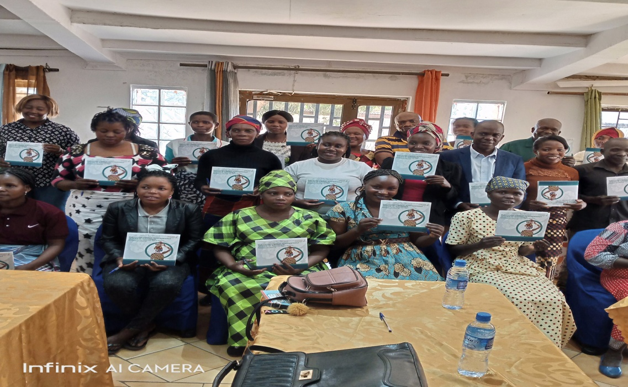
Picture illustrating the Day 1 of training on “Trade Rules and Customs Procedures" in Mandimba.
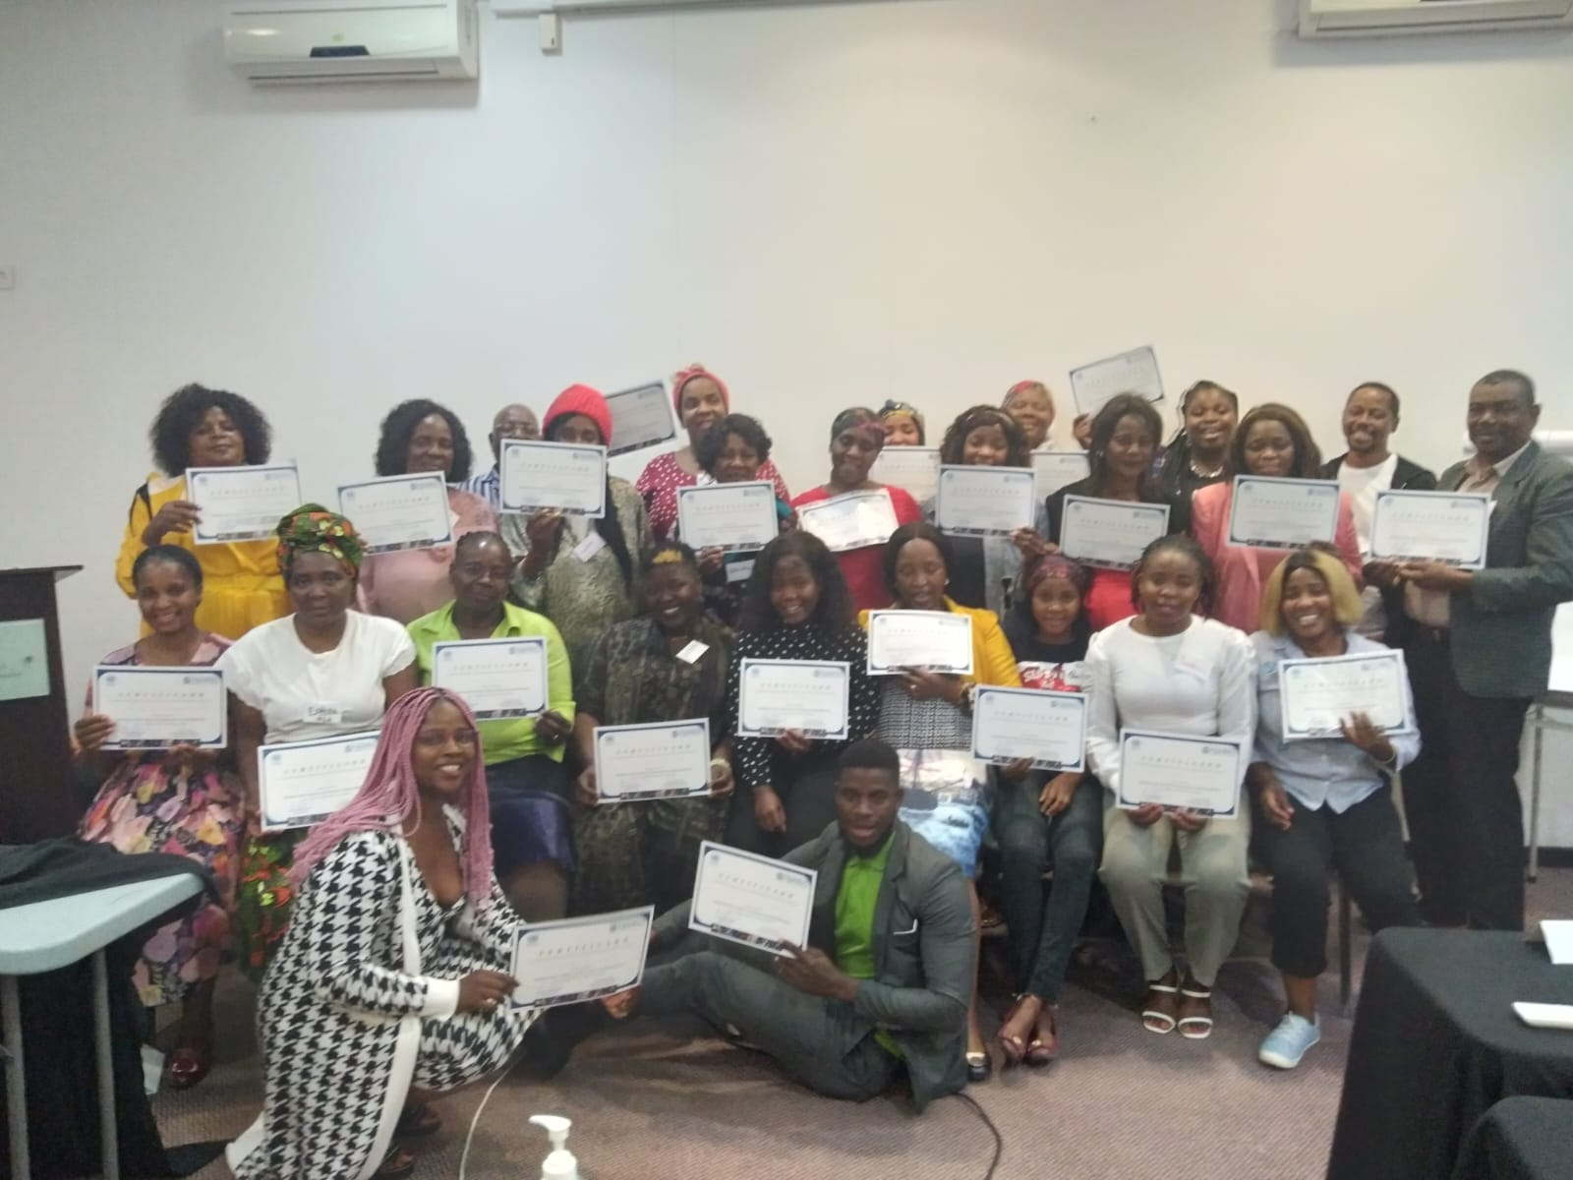
Participants in a group photo in Maputo displaying their certificates after graduation

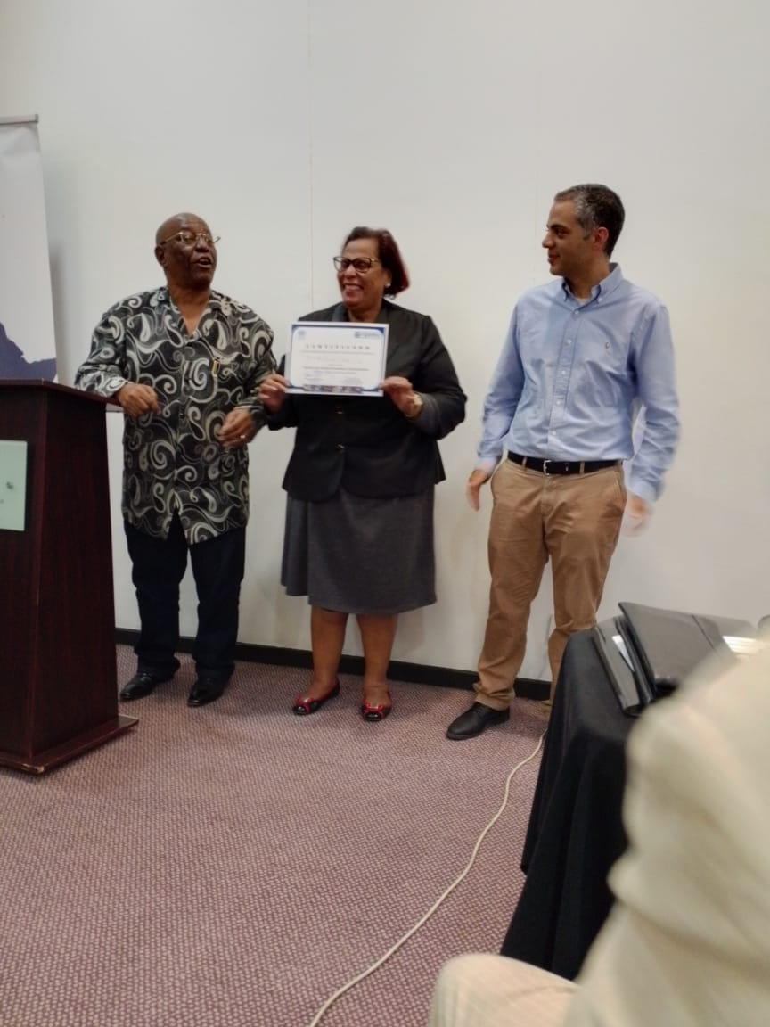
A participant of the 1st group in Maputo displaying her certificate after graduation

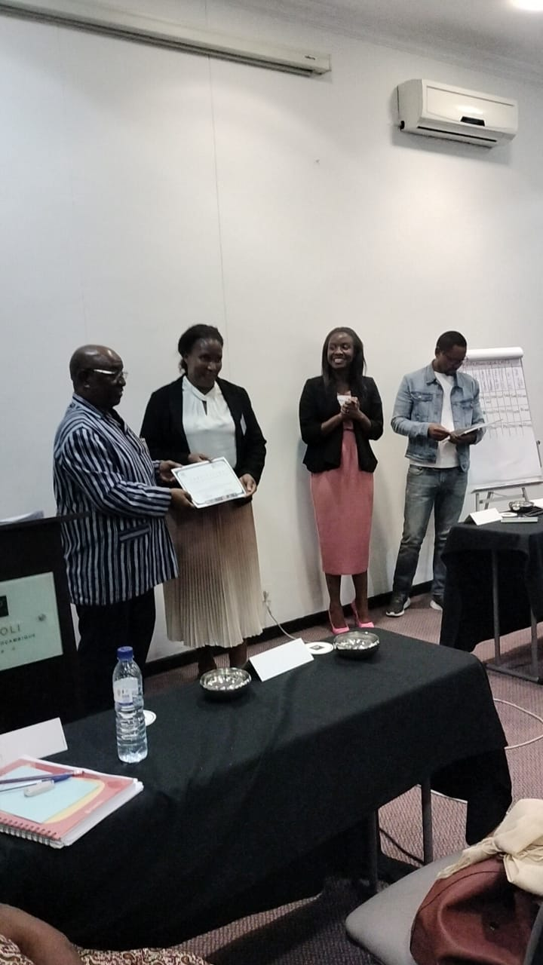
A participant of the 2nd group in Maputo displaying her certificate after graduation
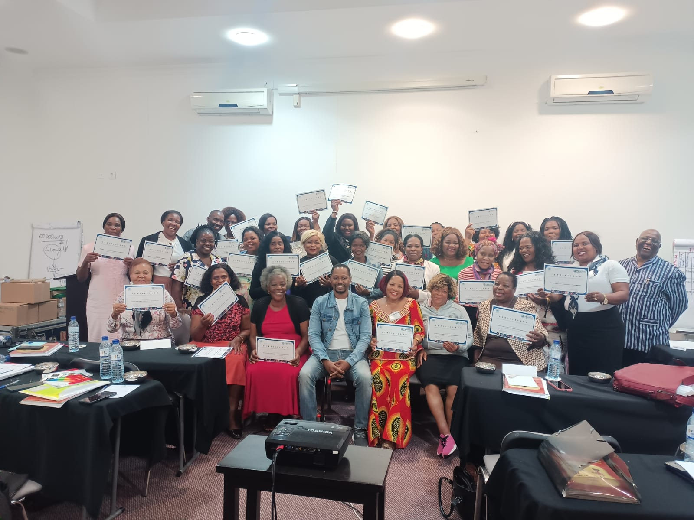
Participants of the 3rd group in Maputo displaying their certificates after graduation

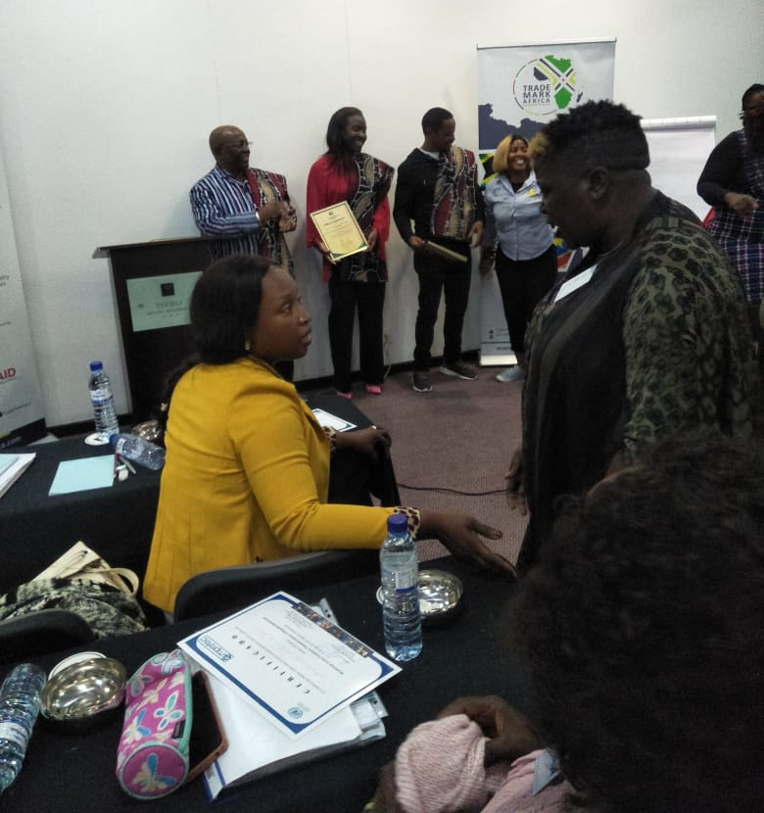
A group of participants presenting offers of recognition to workshops trainers

A pioneering United Nations programme in developing entrepreneurship, Empretec is a mechanism that instills behavioural change into a select group of promising entrepreneurs. It is dedicated to helping micro and small entrepreneurs put their ideas into action and helping fledgling businesses to grow.
The four workshops followed the same patterns and were organized according to the same content and schedule.

